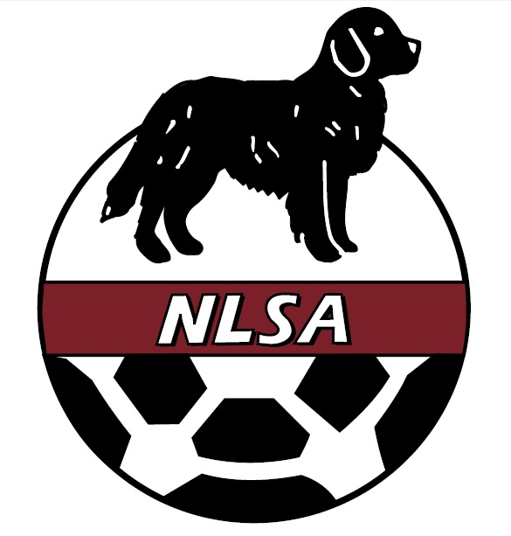 | Newfoundland and Labrador Soccer Association  Nomination to the Executive  Nomination Form – 2020  Deadline to Submit: March 4, 2020 4:00 pm

Nominee
Name
Address
City
Phone
E-mail
Position for Nomination
Nominee’s Declaration: I confirm that the above information is correct and I agree to have my name put forward for consideration by the membership for the position indicated on the NLSA Board of Directors at its next Annual General Meeting.
Signature of Nominee

Nominator
Name
Address
City
Phone
E-mail
Signature of Nominator

Seconder
Name
Address
City
Phone
E-mail
Signature of Seconder

Note: Nominee, Nominator and Seconder, must be members in good standing with the NLSA.

