 TOURNAMENT SCHEDULE 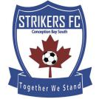
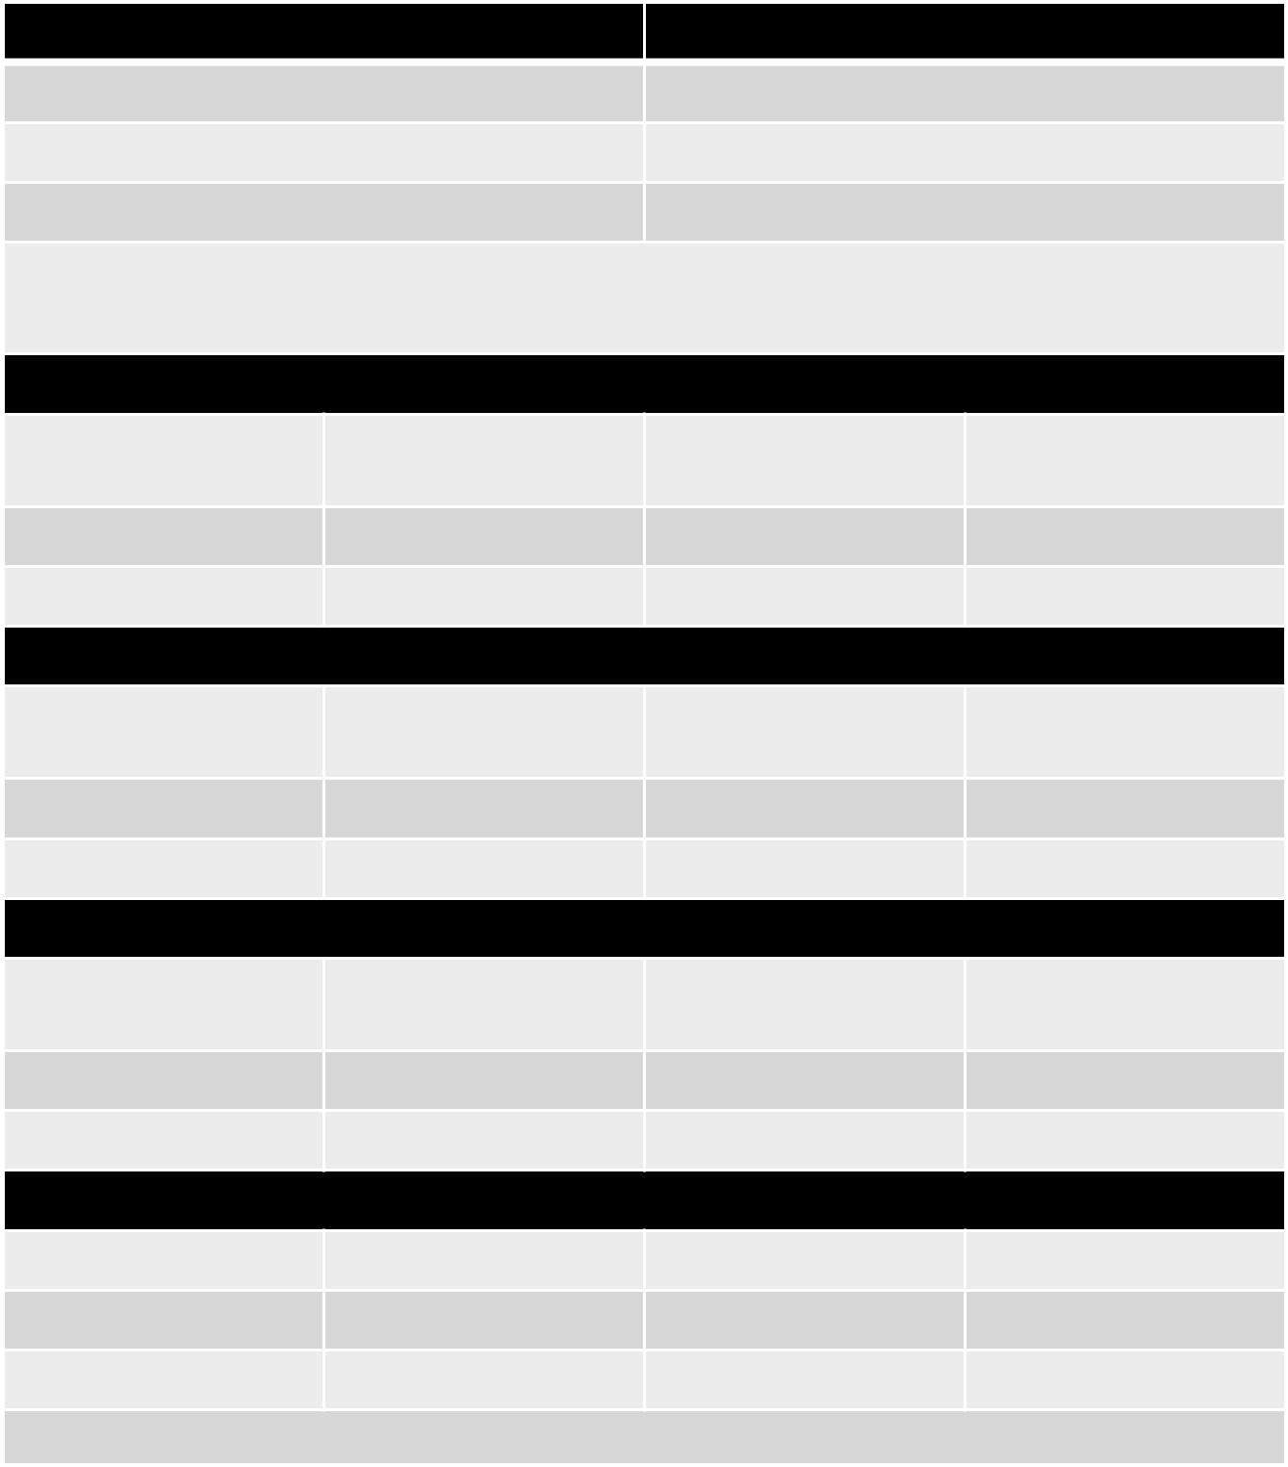

Group A | Group B
Halifax County (NS 1) | Mount Pearl SA (NL 1)
Fredericton (NB 2) | Codiac (NB 1)
CBS Strikers (NL 2) | Suburban (NS 2)

Teams will play a cross-divisional exhibition match vs a team from another province on the day that they do not have a round robin match.

Thursday, September 19

12:00 pm | Cross Divisional | Fredericton | Suburban
12:00 pm | Exhibition | Fredericton | Suburban
2:00 pm | Group B | Mount Pearl | Codiac
4:00 pm | Group A | Halifax County | CBS Strikers
 | Friday, September 20
12:00 pm | Cross Divisional | Halifax County | Mount Pearl
12:00 pm | Exhibition | Halifax County | Mount Pearl
2:00 pm | Group B | Suburban | Codiac
4:00 pm | Group A | CBS Strikers | Fredericton
 | Saturday, September 21
11:00 am | Cross Divisional | CBS Strikers | Codiac
11:00 am | Exhibition | CBS Strikers | Codiac
1:00 pm | Group B | Suburban | Mount Pearl
3:00 pm | Group A | Fredericton | Halifax County
 | Sunday, September 22
9:00 am | 5 / 6th | 3rd Group A | 3rd Group B
11:00 am | Bronze / 4th | 2nd Group A | 2nd Group B
1:00 pm | Gold / Silver | 1st Group A | 1st Group B

Sunday schedule subject to change based on flight schedules

www.nlsa.ca

